CSE0001 – Digital Literacy

Task 3 — Coding & Collaboration Platforms
Yuvraj Dixit | 25BEC10100 | B.Tech CSE | VIT Bhopal University

Platform Screenshots

Part A — Coding Practice Platform: HackerRank

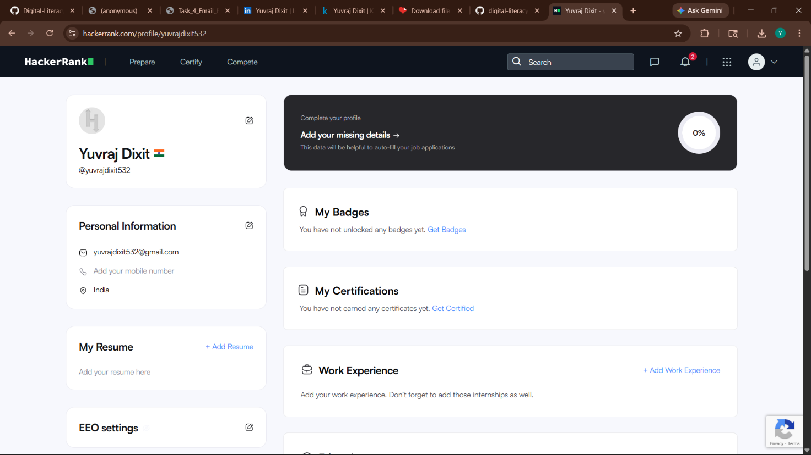
Figure 1: HackerRank Profile — Yuvraj Dixit | Account created and ready to attempt coding challenges and skill certifications

Part B — Google Workspace Collaboration: Digital Literacy Quiz

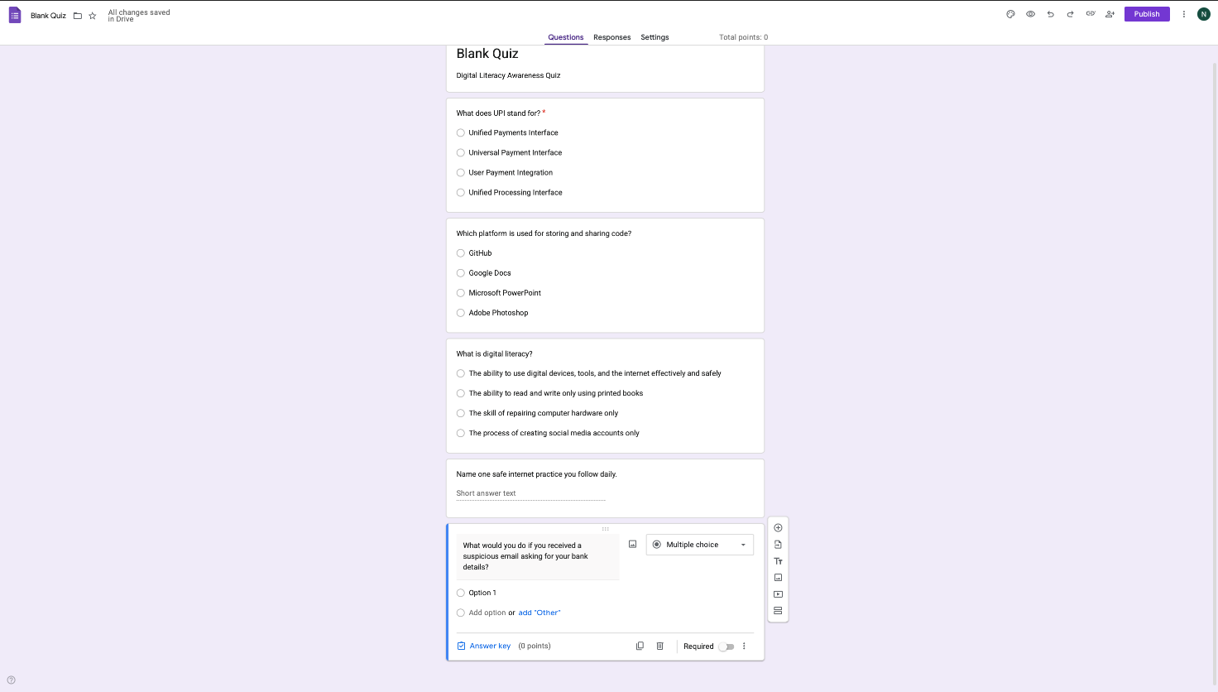

Figure 2: Google Form — ‘Digital Literacy Awareness Quiz’ | 5-question quiz created for batchmates covering 2FA, phishing, GitHub, email etiquette, and digital literacy

Task 3 Write-Up
For Task 3, I worked with two platforms: HackerRank for coding practice and Google Forms for cloud-based collaboration. For Part A, I created an account on HackerRank . HackerRank is widely used for practising coding problems and preparing for
technical interviews. It offers structured challenges in Python, C++, and Java, along with skill certifications recognised by companies. This platform will help me strengthen my problem-solving skills as I begin learning programming, and I plan to attempt challenges regularly to earn badges I can display on LinkedIn and my resume.
For Part B, I used Google Forms to create a five-question ‘Digital Literacy Awareness Quiz’ for my batchmates, covering topics like 2FA, phishing, GitHub, and email etiquette. The quiz includes three MCQs and two short answer questions, linked to a Google Sheet to track responses automatically. Google Forms is a highly useful academic tool for surveys, quizzes, and feedback collection — all without any technical setup. This task gave me hands-on experience with Google Workspace, which I will continue using throughout my four years at VIT Bhopal for assignments, group projects, and collaboration.

End of Task 3 | CSE0001 – Digital Literacy | VIT Bhopal University

